Table of Contents

1 Sales Module User Manual

1.1 1. Role Objective
The Sales role is responsible for accurate ticket intake, client call verification, priority setup, and post-handoff resolution monitoring until ticket completion.

1.2 2. Module List (Sales)
- Login
- Dashboard
- Create Ticket
- Tickets
- Clients
- Products
- Device/Equipment Categories
- Types of Service (view/selection support during ticket creation)
- Closing and Completed Ticket Views (monitoring)
- Sales Resolution Monitoring Workflow

1.3 3. Login Module
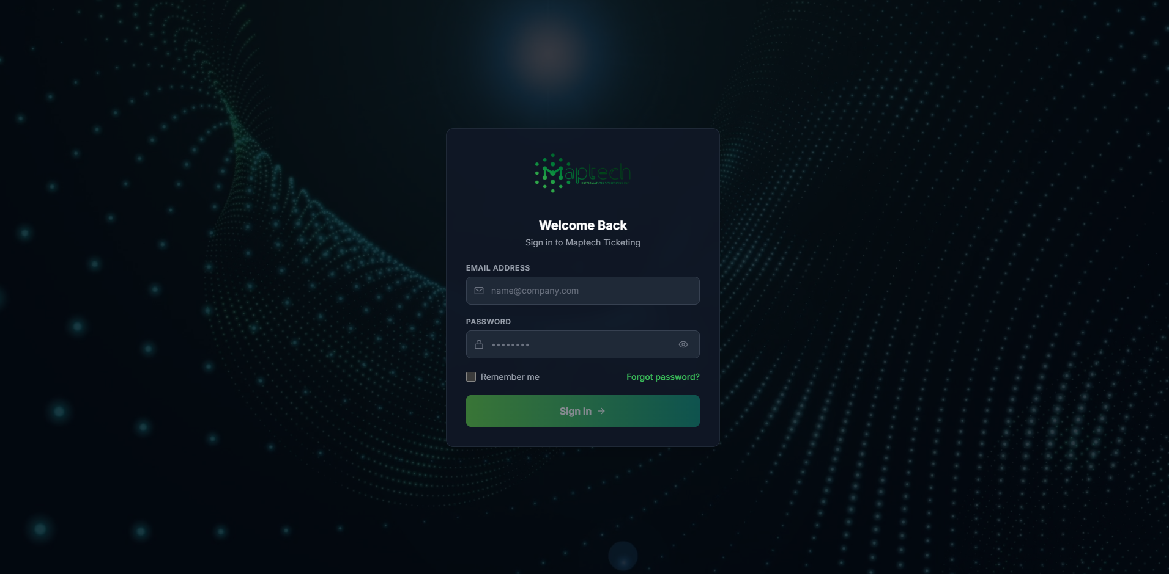
Sales Login
Steps: 1. Enter registered email/username and password. 2. Click Sign In. 3. Confirm successful redirect to Sales dashboard.

1.4 4. Dashboard Module
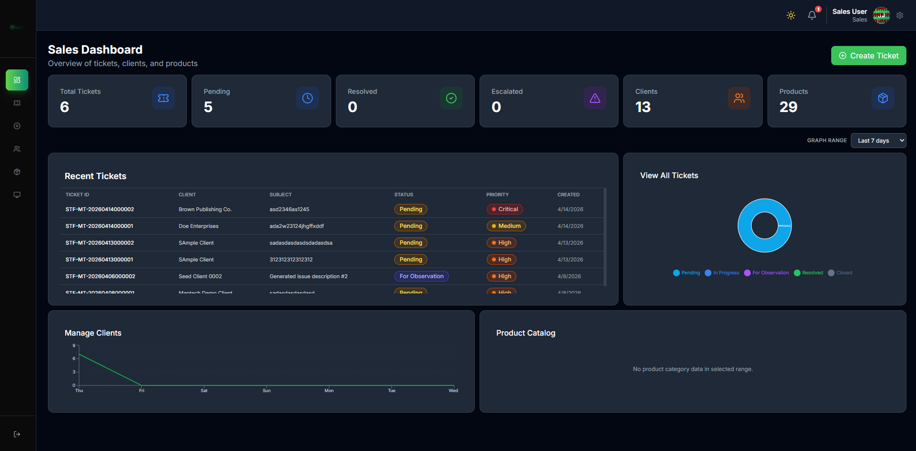
Sales Dashboard
Purpose: - View overall ticket intake health. - Monitor pending/escalated/resolved counts. - Track recent ticket activity and basic trends.
Daily Checklist: 1. Check total pending tickets. 2. Review tickets with high and critical priority. 3. Open tickets requiring call verification completion.

1.5 5. Create Ticket Module (Core Sales Workflow)

1.5.1 5.1 Entry Point
Create ticket from dashboard quick action or ticket module action.

1.5.2 5.2 Step 1: Client Information

1.5.2.1 New Client Path
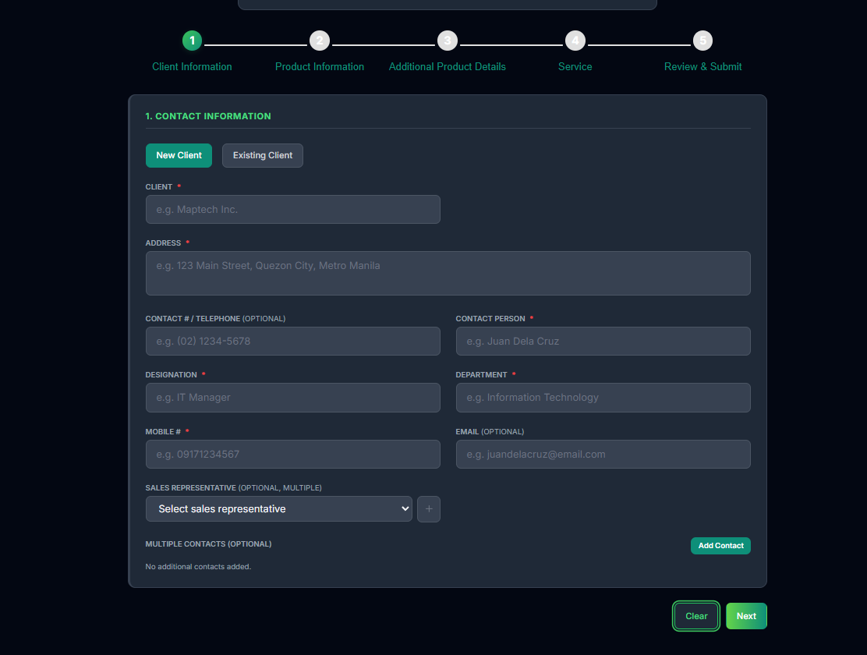
Sales Create Ticket New Client
Flow Lines: - Flow Line 1.1: Select New Client. - Flow Line 1.2: Enter required client information. - Flow Line 1.3: Add sales representative and optional additional contacts.

1.5.2.2 Existing Client Path
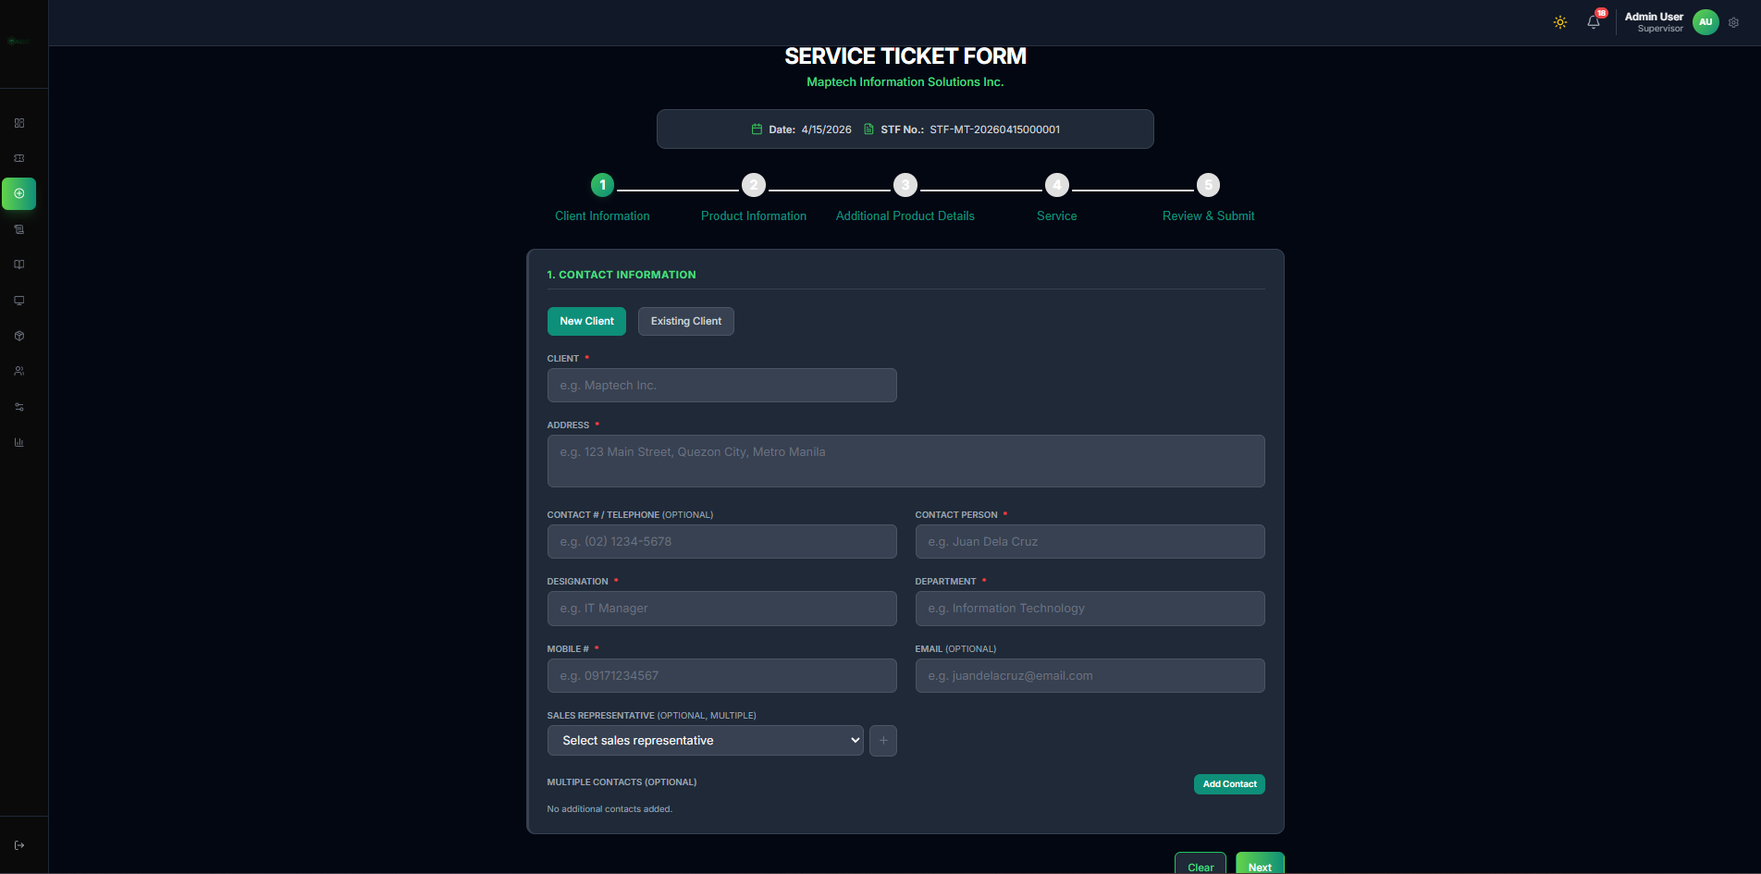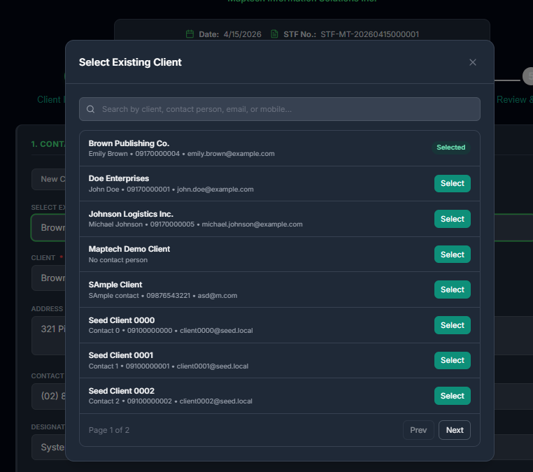
Flow Lines: - Flow Line 1.4: Select Existing Client. - Flow Line 1.5: Search and select target client in modal. - Flow Line 1.6: Verify pre-filled contact details before proceeding.

1.5.3 5.3 Step 2: Product Information

1.5.3.1 New Product Path
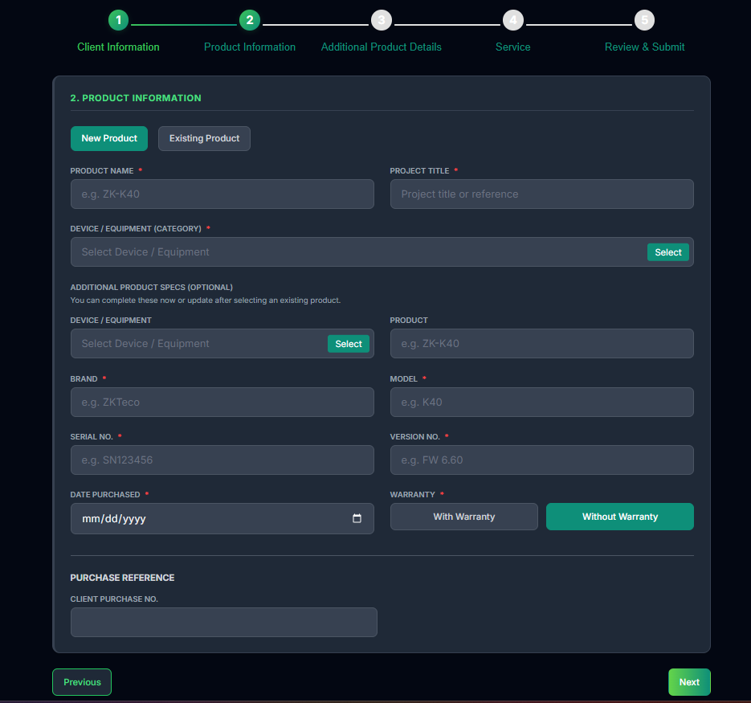
Sales Create Ticket New Product
Flow Lines: - Flow Line 2.1: Choose New Product. - Flow Line 2.2: Enter product name, project title, category, brand/model, serial, date purchased, and warranty.

1.5.3.2 Existing Product Path
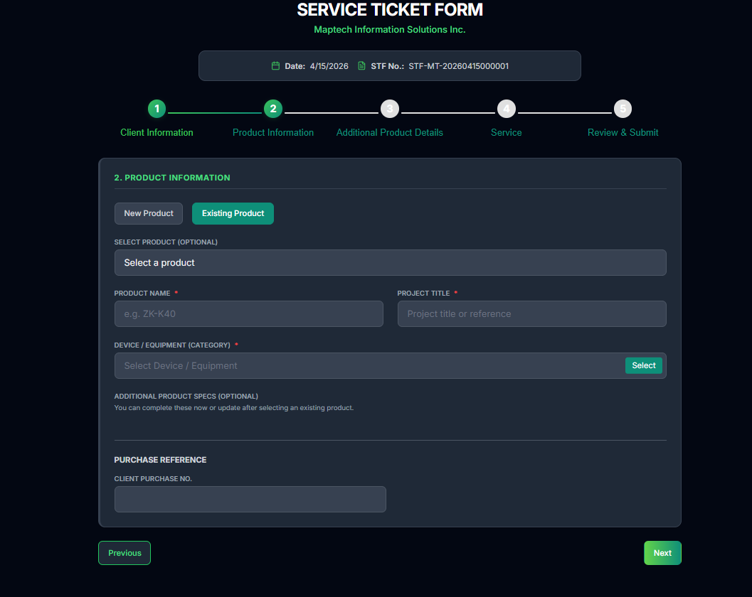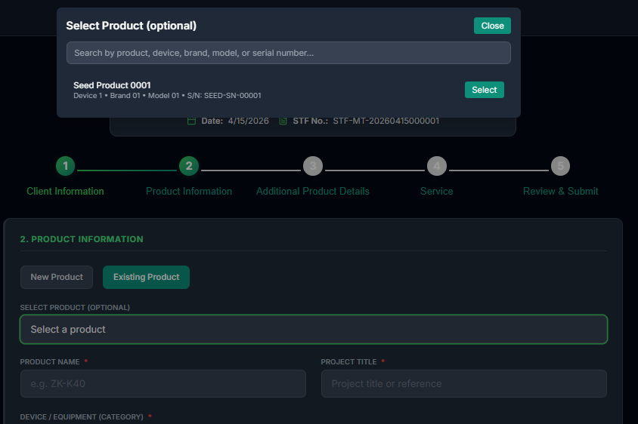
Flow Lines: - Flow Line 2.3: Choose Existing Product. - Flow Line 2.4: Open product selector modal and search by product/device/brand/model/serial. - Flow Line 2.5: Select product and verify loaded fields.

1.5.4 5.4 Step 3: Additional Product Details
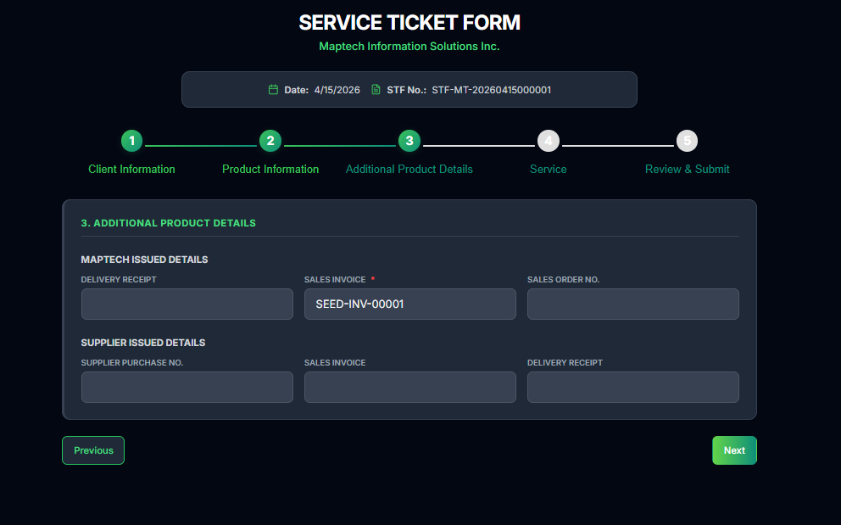
Sales Additional Product Details
Flow Lines: - Flow Line 3.1: Encode maptech and supplier issued details. - Flow Line 3.2: Confirm invoice and receipt references are accurate.

1.5.5 5.5 Step 4: Type of Service
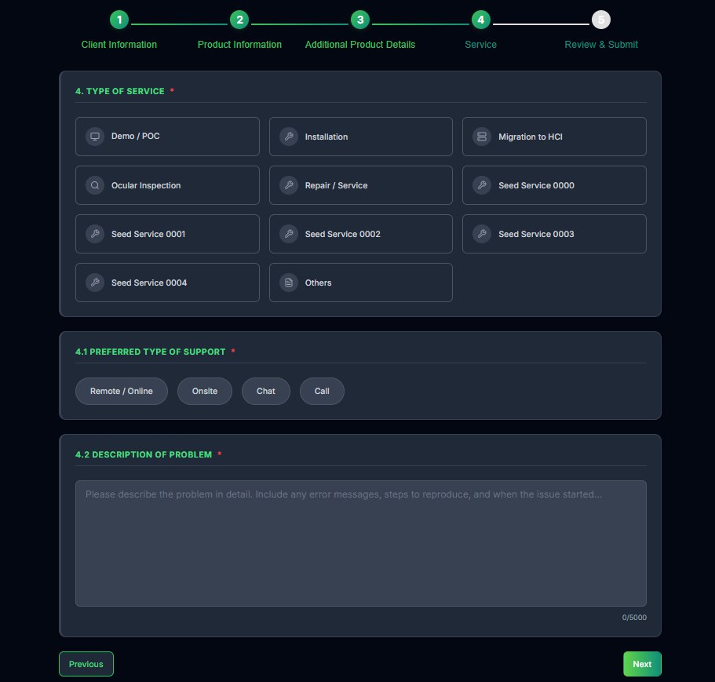
Sales Type of Service
Flow Lines: - Flow Line 4.1: Select service type. - Flow Line 4.2: Select preferred support mode (remote/on-site/chat/call). - Flow Line 4.3: Write detailed problem description.

1.5.6 5.6 Step 5: Review and Submit
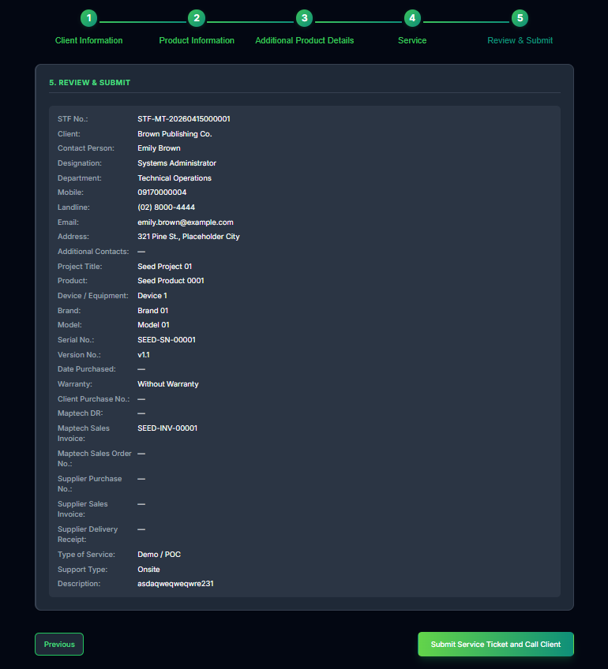
Sales Review and Submit
Flow Lines: - Flow Line 5.1: Review all sections line-by-line. - Flow Line 5.2: Verify client, product, and service data. - Flow Line 5.3: Submit service ticket and call client. - Flow Line 5.4: Confirm STF number generated.

1.5.7 5.7 Sales Handoff Process (Critical)
Flow Line H1: Complete call verification and ticket review.
Flow Line H2: Set proper priority (Critical, High, Medium, Low, Unknown).
Flow Line H3: Confirm ticket for supervisor assignment.
Flow Line H4: Monitor ticket in Sales views until closure.

1.6 6. Tickets Module
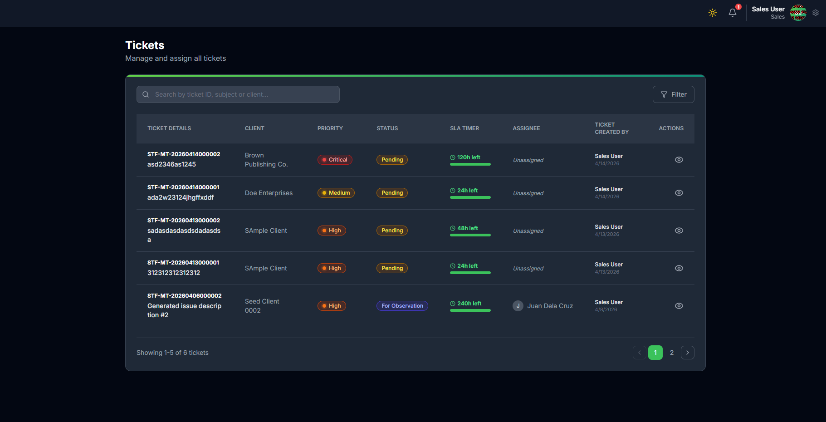
Sales Tickets
Purpose: - View tickets created or visible to Sales scope. - Search and filter by ticket ID, subject, or client. - Monitor resolution progress after supervisor and technical handling.
Steps: 1. Use search/filter for quick lookup. 2. Open ticket details from action column. 3. Confirm status progression after supervisor/technical actions. 4. Track whether ticket is in Open, In Progress, Escalated, Escalated External, For Observation, Pending Closure, Closed, or Unresolved. 5. Ensure high-priority tickets are not stalled and follow up when progress is delayed.

1.6.1 6.1 Resolution Monitoring in Tickets Module
Resolution Flow Lines: - Flow Line R1: Open ticket from Sales list after handoff. - Flow Line R2: Validate ticket moved from intake state to operational state (In Progress or equivalent active handling state). - Flow Line R3: Check if ticket transitions to Pending Closure after technical resolution. - Flow Line R4: If ticket returns to escalation path (Escalated or Escalated External), document follow-up and coordinate with supervisor. - Flow Line R5: If ticket is marked Unresolved, coordinate status clarification and reopen direction when applicable. - Flow Line R6: Confirm final movement to Closed in ticket history.

1.7 7. Clients Module
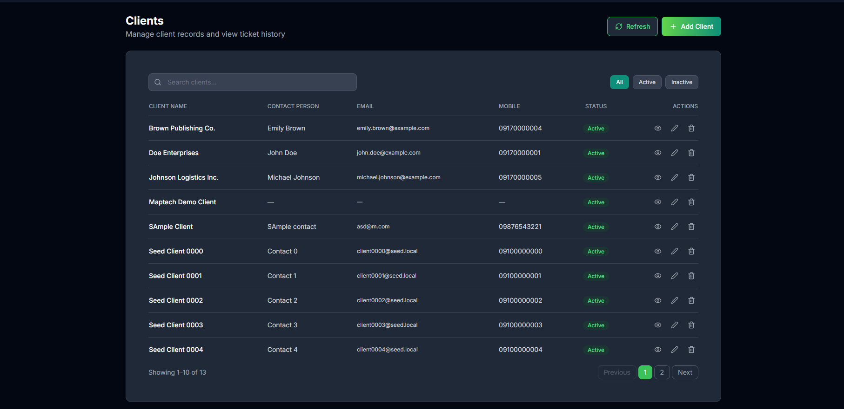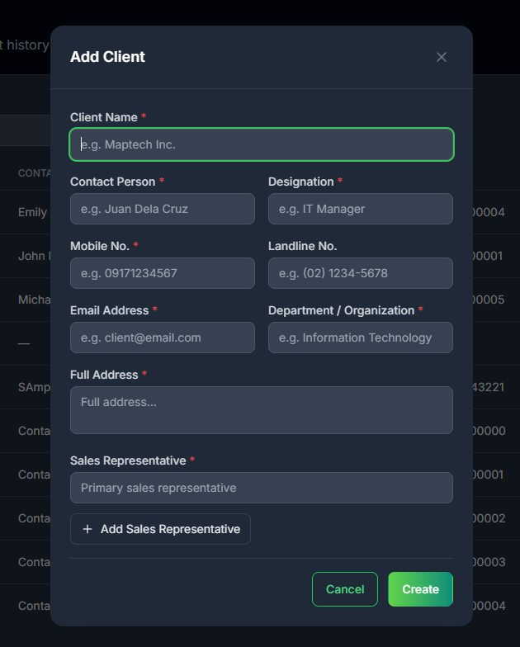
Purpose: - Maintain accurate client master records.
Steps: 1. Click Add Client. 2. Fill required fields (client, contact, designation, mobile, department, full address, sales rep). 3. Save and verify in table list. 4. Use view/edit/delete actions as needed.

1.8 8. Products Module
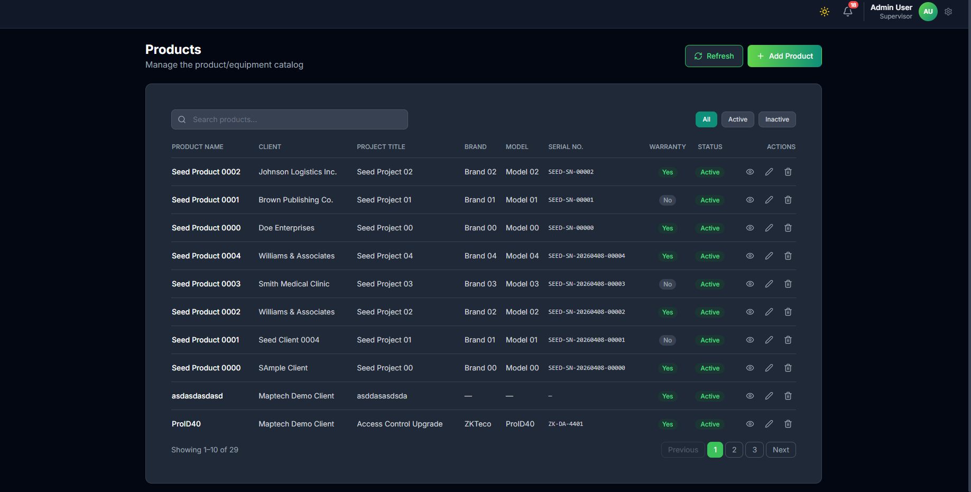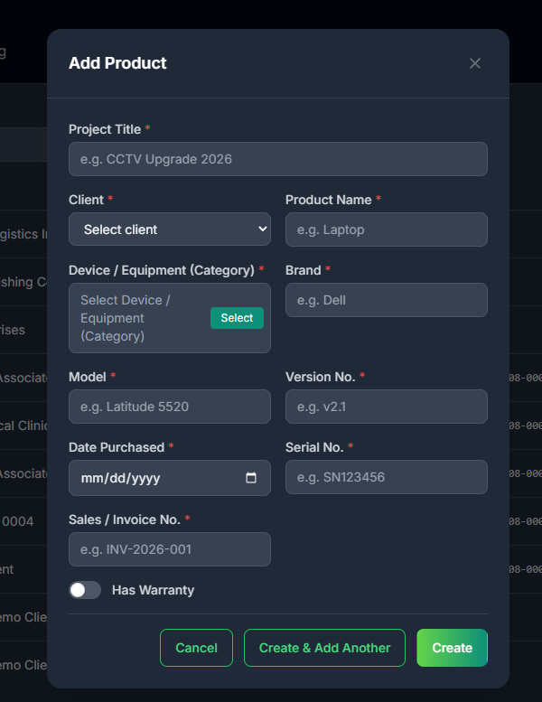
Purpose: - Maintain product/equipment records linked to clients and tickets.
Steps: 1. Click Add Product. 2. Choose client and category. 3. Encode product details and warranty state. 4. Save and verify catalog entry.

1.9 9. Device/Equipment Category Module
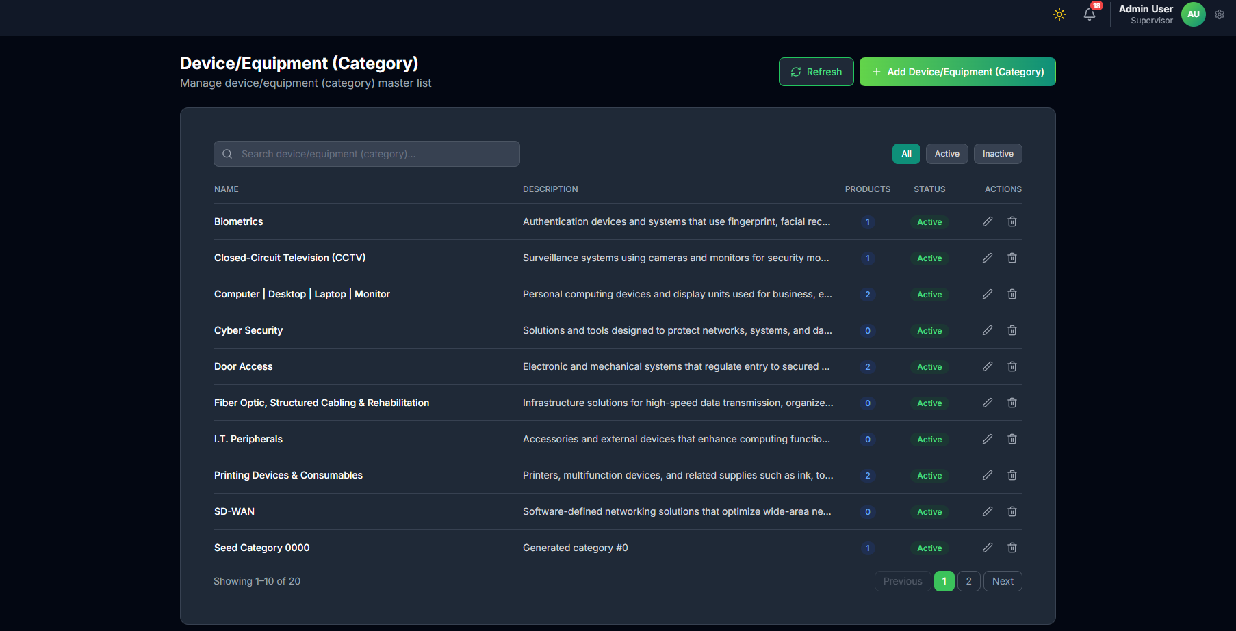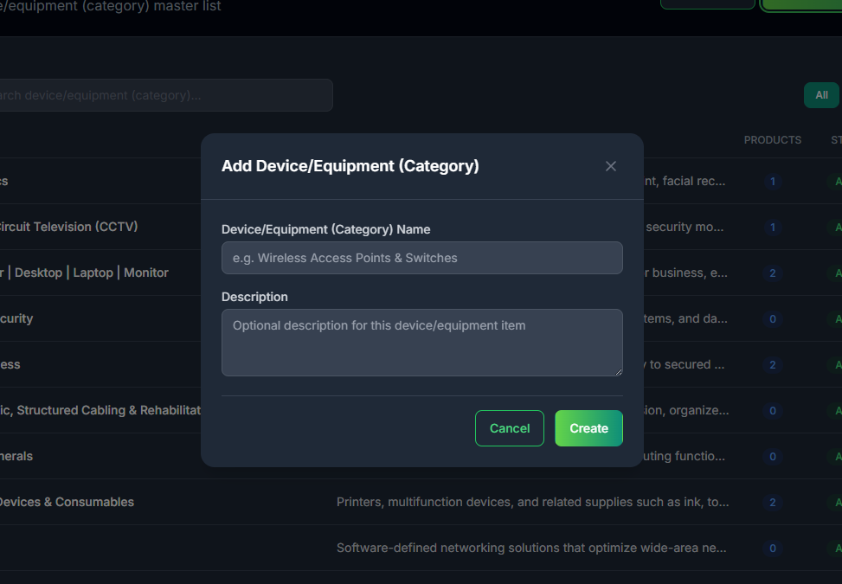
Purpose: - Maintain category list used by product registration and ticket intake.
Steps: 1. Add category name and description. 2. Keep descriptions specific for accurate selection. 3. Activate/deactivate categories as needed.

1.10 10. Types of Service Module
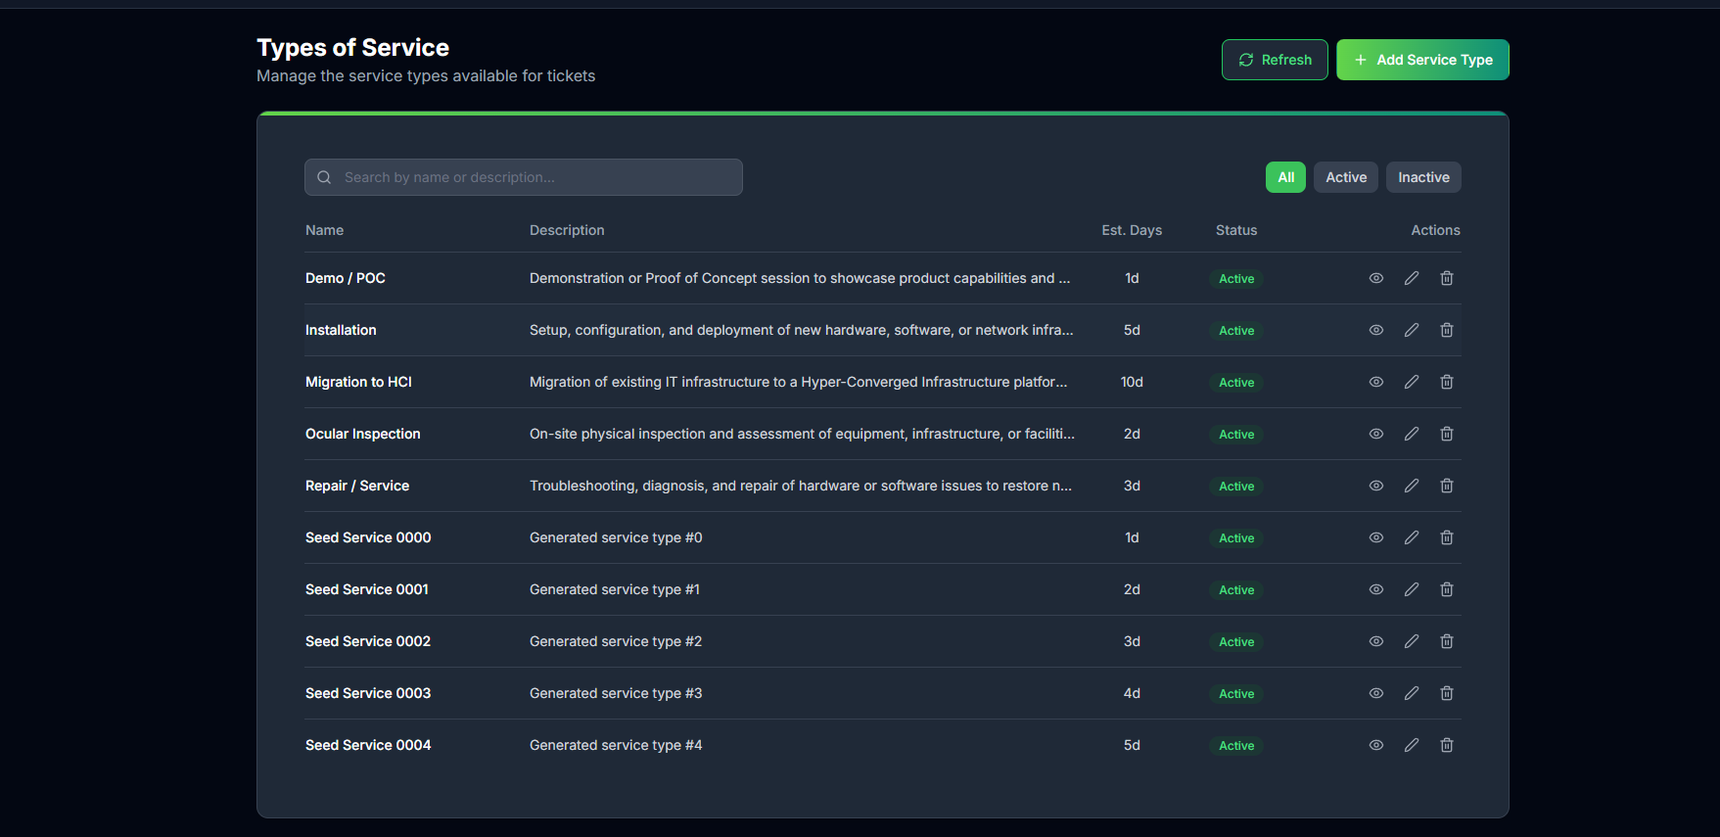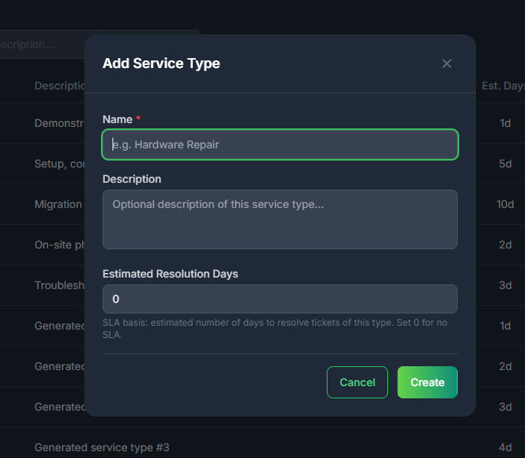
Purpose: - View service definitions and estimated resolution day references.
Usage in Sales Flow: 1. During ticket creation, choose the closest matching service type. 2. Ensure selected service type aligns with client issue.

1.11 11. Closing and Completed Tickets Views
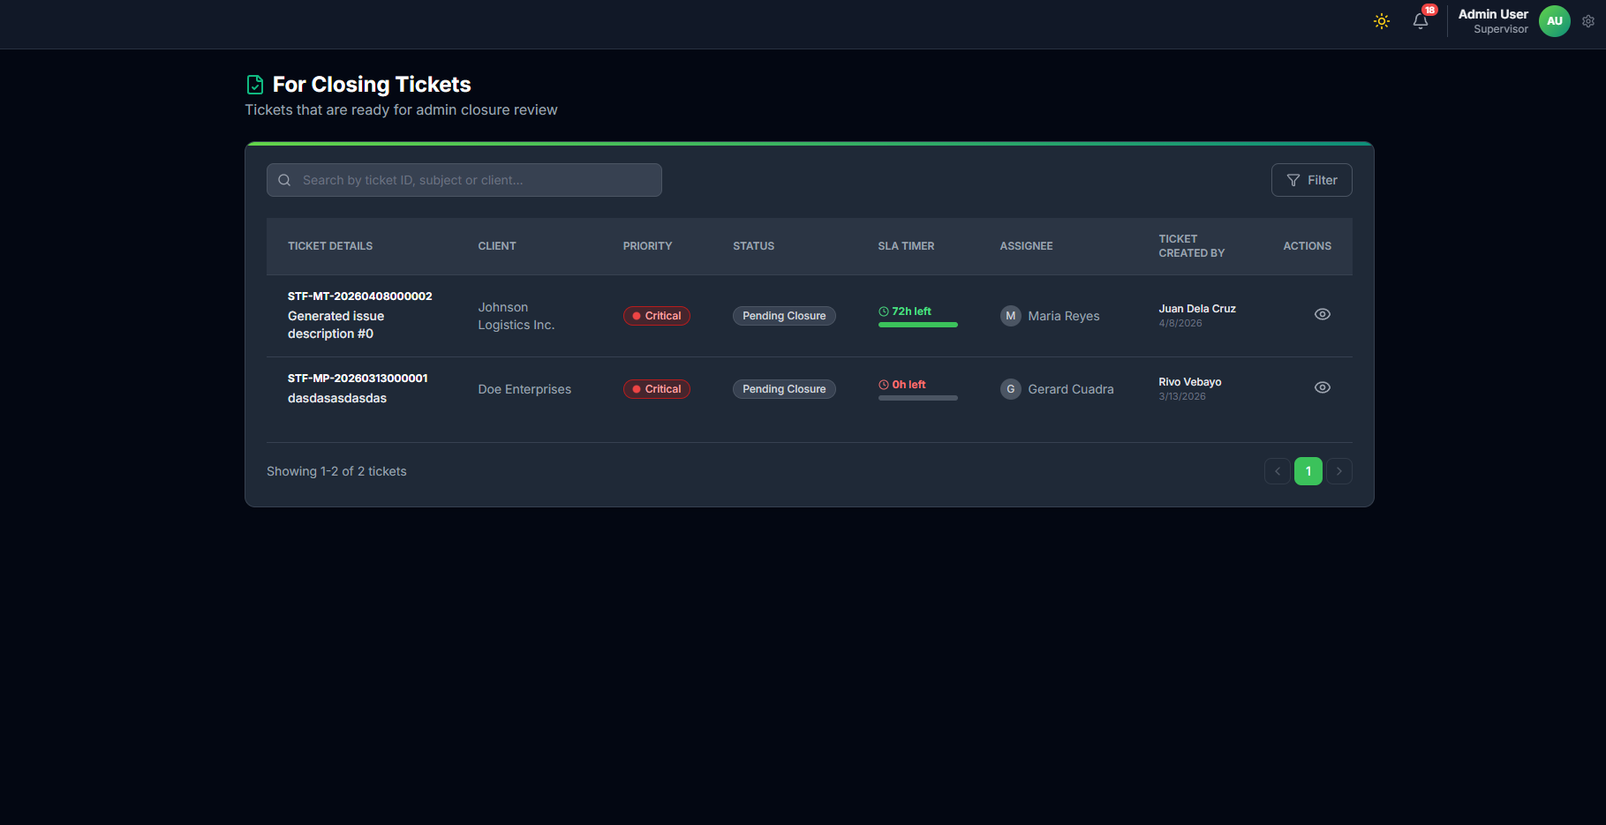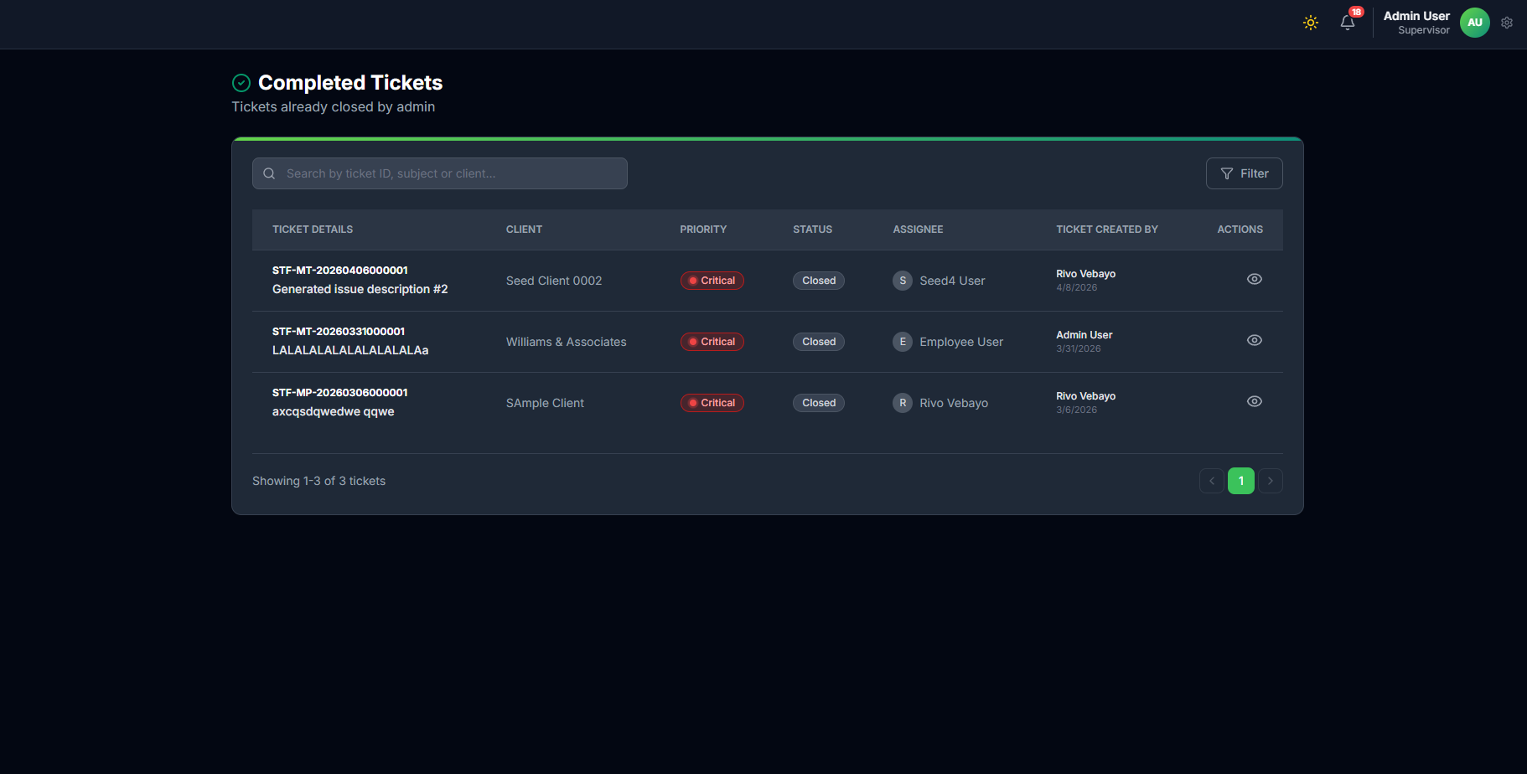
Purpose: - Monitor tickets awaiting closure review and finalized tickets.
Closing View Steps: 1. Open Closing Tickets to see tickets in supervisor review phase. 2. Confirm key details (client, priority, assignee, and SLA context). 3. Flag overdue or blocked tickets for follow-up.
Completed View Steps: 1. Open Completed Tickets to verify final closure. 2. Confirm the resolved ticket appears in completed history. 3. Use completed records for client updates and reference.
Sales Resolution Flow Lines (Closing to Completed): - Flow Line C1: Ticket enters Closing Tickets after technical closure request. - Flow Line C2: Supervisor validates evidence and finalizes closure. - Flow Line C3: Ticket moves to Completed Tickets once closed. - Flow Line C4: Sales confirms final outcome and communicates completion to stakeholders as needed.

1.12 12. Data Accuracy Rules for Sales
- Do not submit incomplete client identity fields.
- Ensure product serial/model is accurate when available.
- Use the correct type of service to avoid SLA misalignment.
- Confirm priority after call verification before final handoff.

1.13 13. Sales Workflow Summary Lines
Flow Line S1: Login -> Dashboard check.
Flow Line S2: Create ticket -> client section.
Flow Line S3: Complete product and service sections.
Flow Line S4: Review and submit ticket.
Flow Line S5: Perform call verification and priority setup.
Flow Line S6: Confirm ticket for supervisor assignment.
Flow Line S7: Monitor ticket progression in Tickets module.
Flow Line S8: Track closure queue in Closing Tickets.
Flow Line S9: Confirm finalized result in Completed Tickets.

1.14 14. Sales Resolution Monitoring Workflow (Per Module)
Module Line M1 (Dashboard): Track pending and escalated counts daily.
Module Line M2 (Tickets): Verify movement from active handling to closure path.
Module Line M3 (Closing Tickets): Watch tickets waiting for supervisor final decision.
Module Line M4 (Completed Tickets): Confirm closure completion and archive-ready status.
Module Line M5 (Clients/Products): Ensure resolved record context remains accurate for future ticket intake.

